Sprint 1 Testing

The website was tested using Testing Whiz.

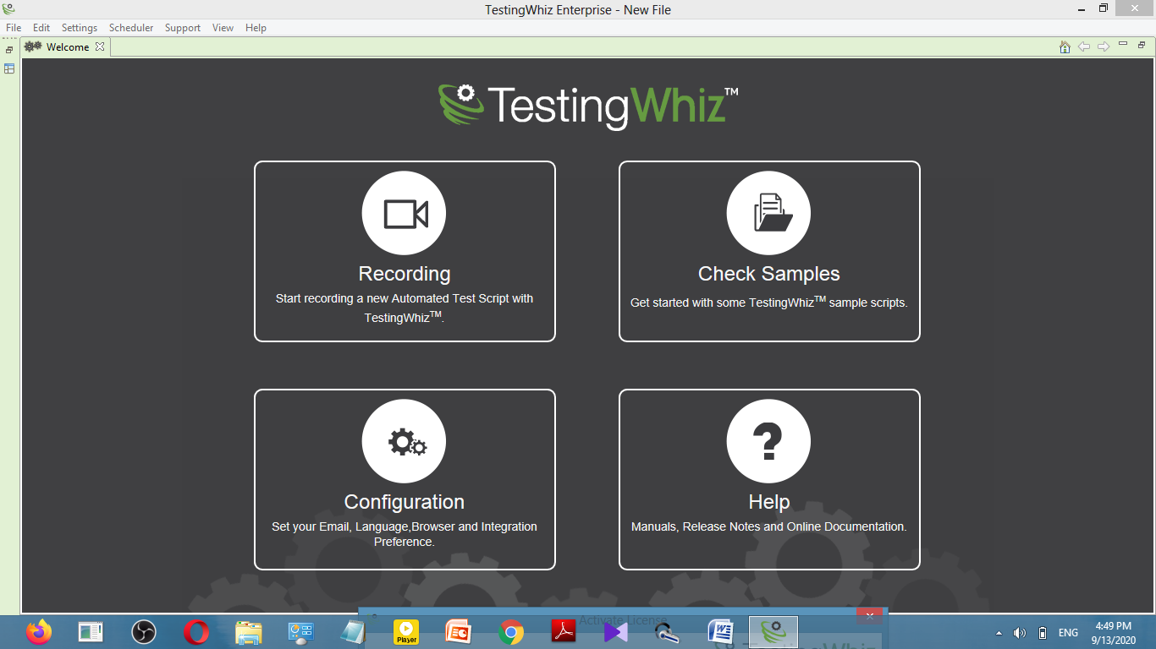

After testing, everything was working correctly.

This is the academics page which is working properly with all the gifs in the background

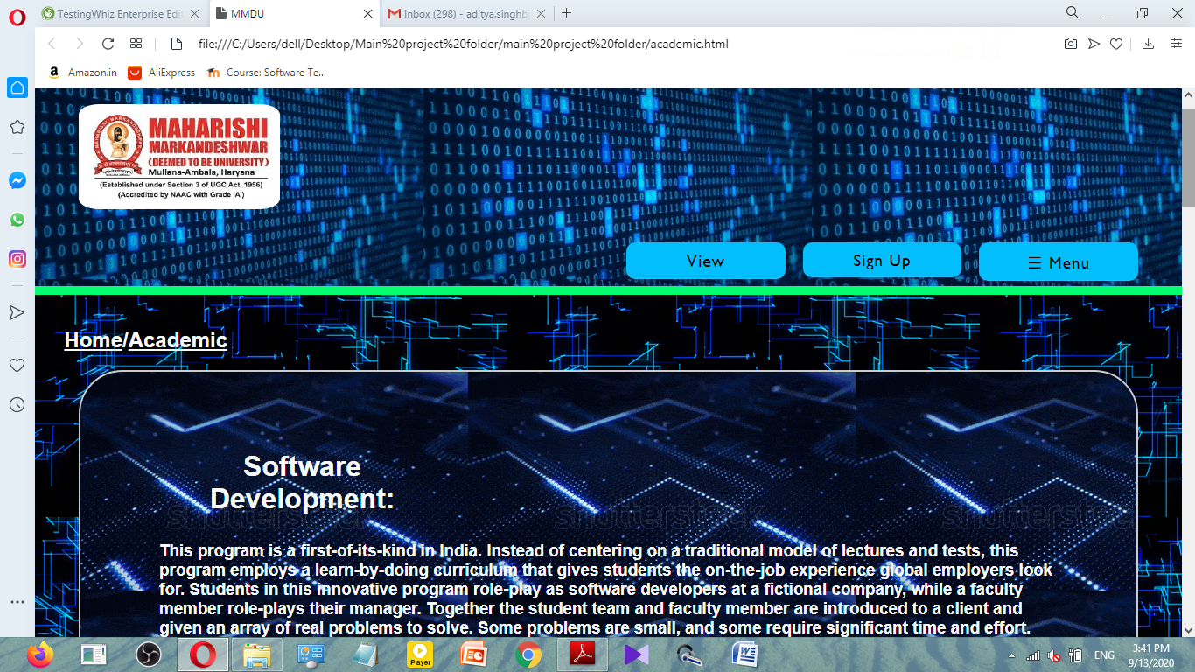

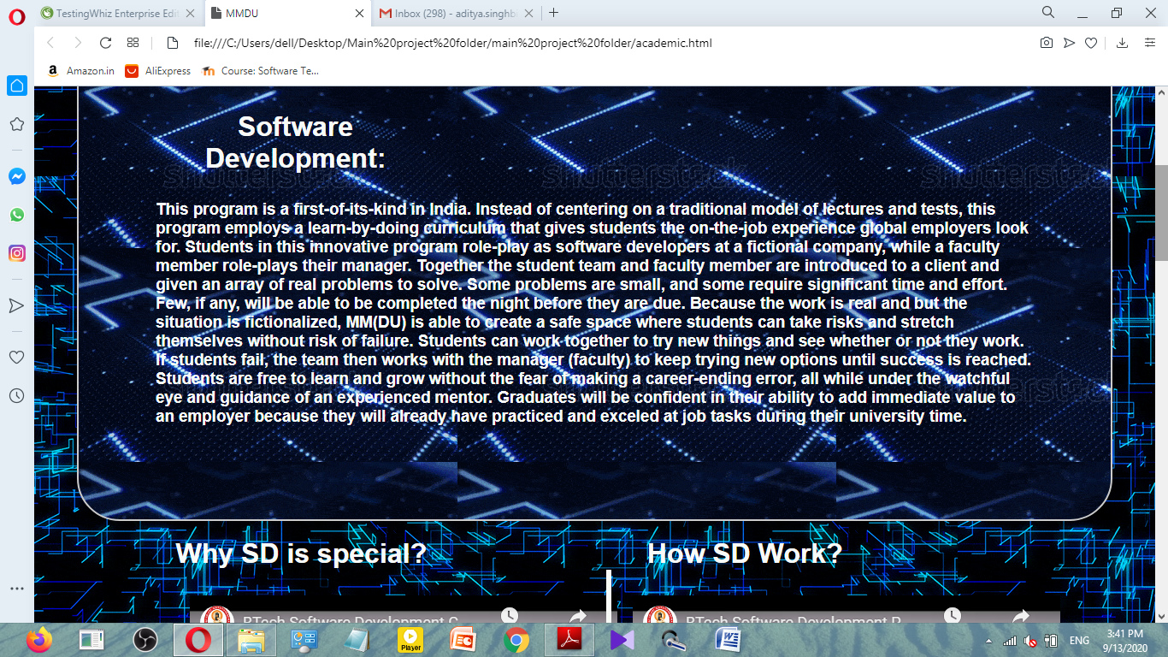

The videos of SD are working properly too.

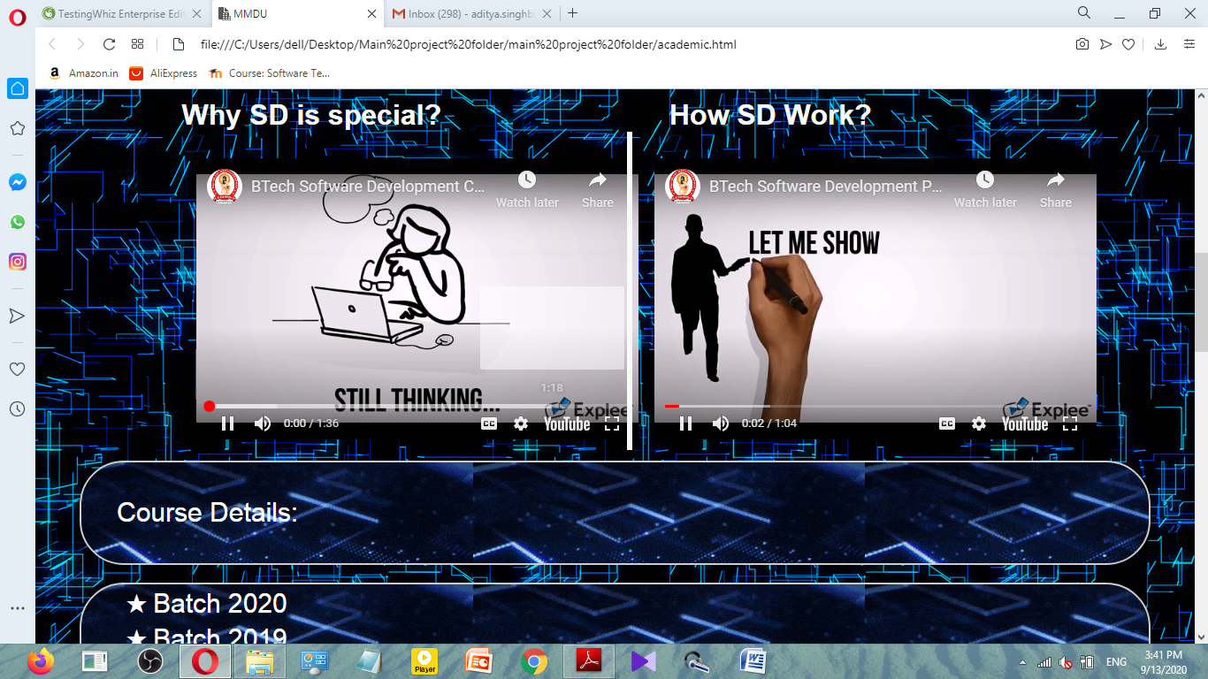

Nested list has been used for Course Details



Pie chart has been created for showing the grading criteria

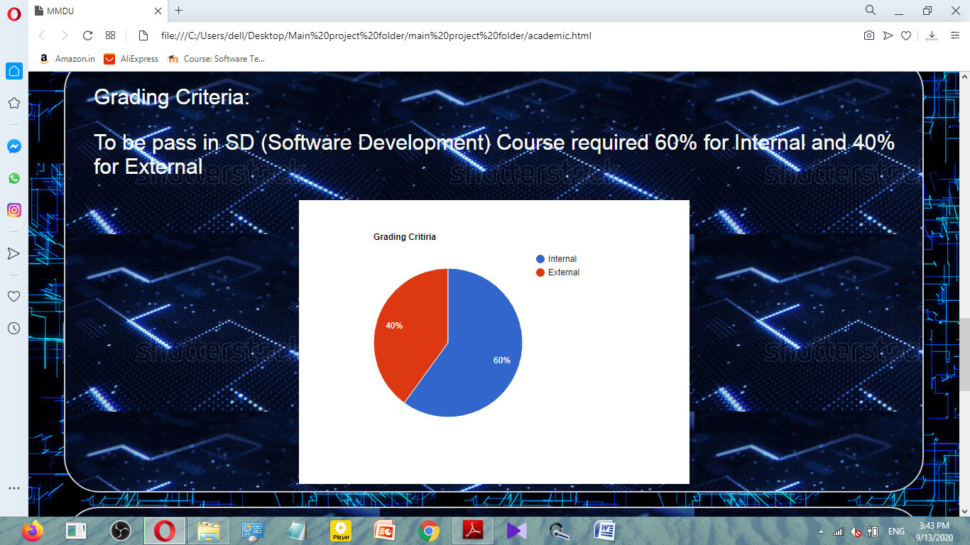

A form for submitting query is created

It will show error if the email field is not filled

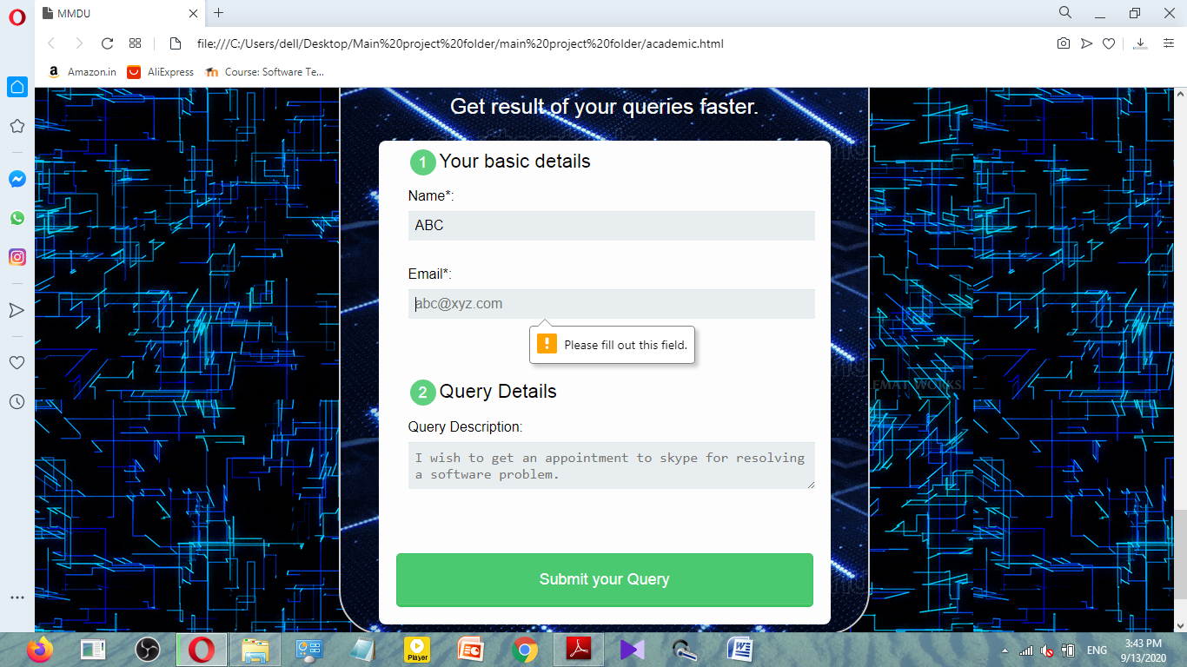

Once the fields are filled then the query can be submitted

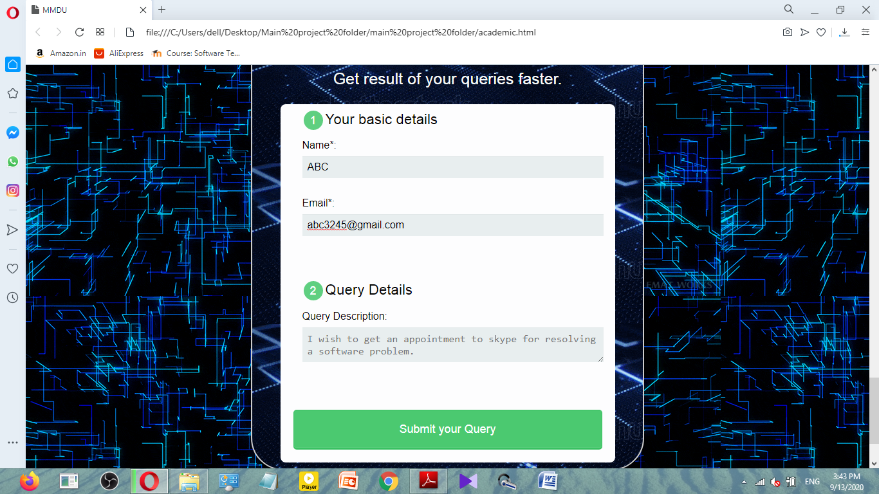

User can go to the faculty page from the menu

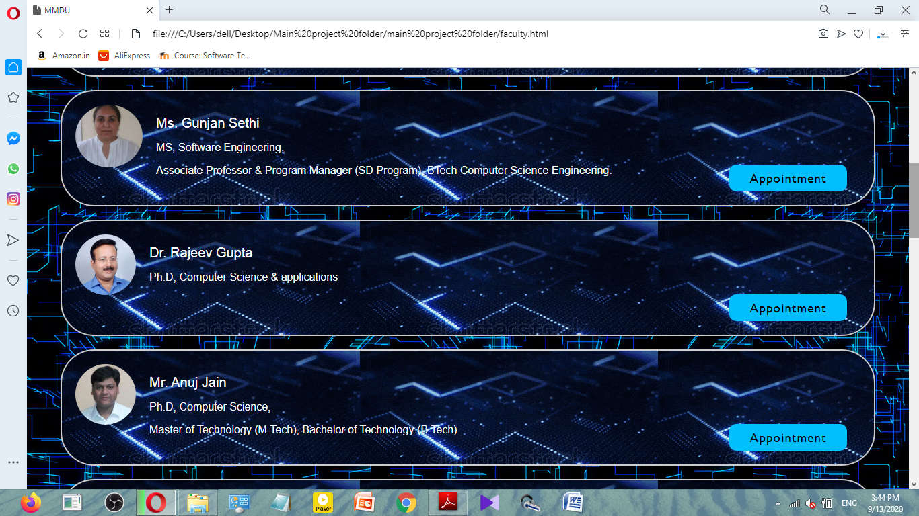

The user can also request for appointment with faculty member through the appointment form

However the appointment form will not be submitted if the fields are empty

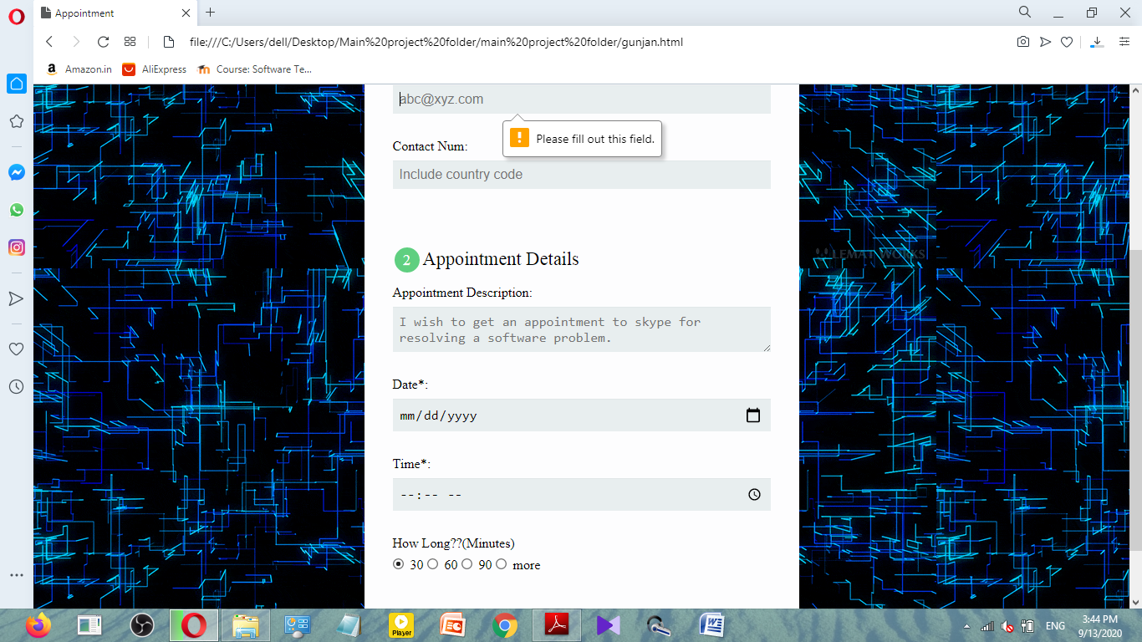

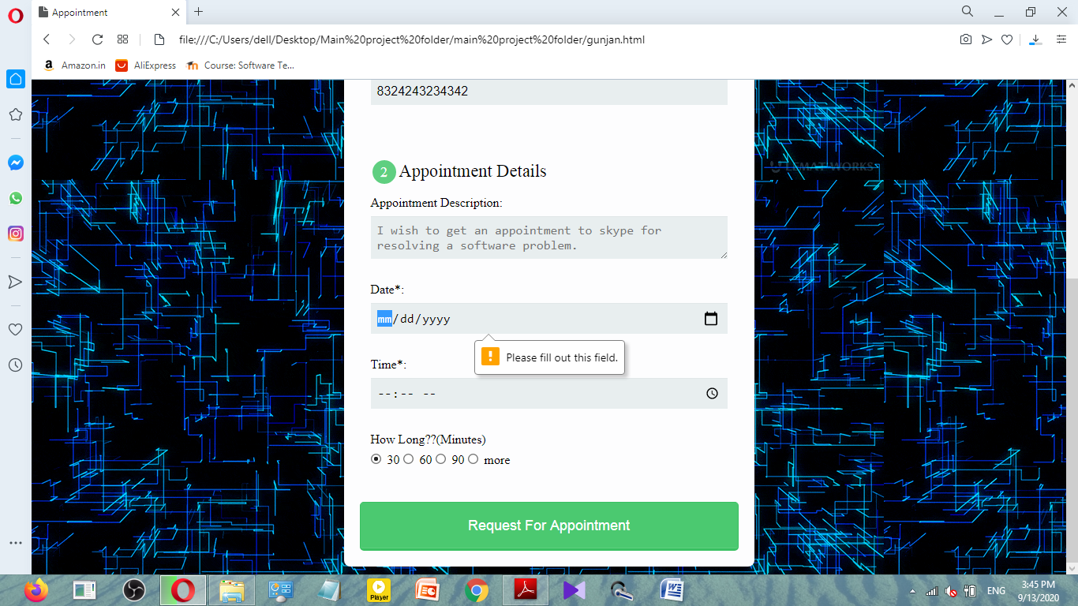

Once all the fields have been filled then we user can request for appointment

The user can also logout from the menu

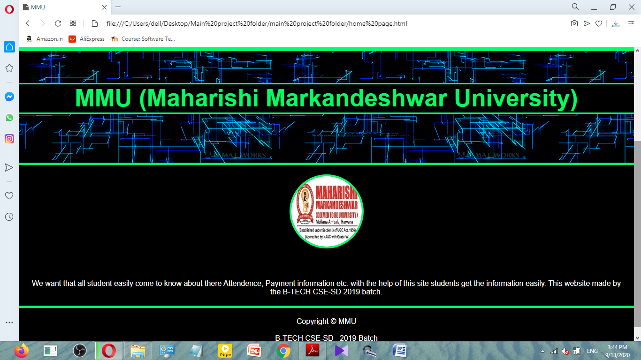

The report from Testing Whiz

